**Day 5**

1. GROUP BY with WHERE - Orders by Year and Quarter

Display, order year, quarter, order count, avg freight cost only for those orders where freight cost > 100

**Query:**

select

extract(YEAR from order_date) as order_year,

extract(quarter from order_date) as order_quarter,

count(order_id),avg(freight)

from orders

where freight > 100

group by order_year,order_quarter

order by order_year,order_quarter;

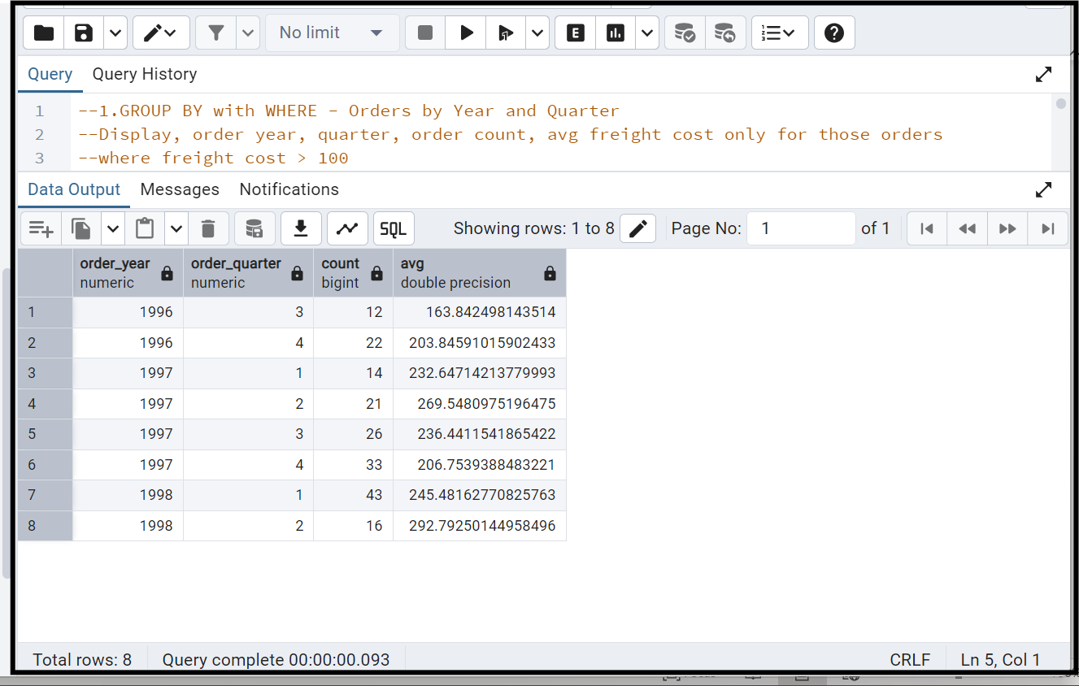

2. GROUP BY with HAVING - High Volume Ship Regions

Display, ship region, no of orders in each region, min and max freight cost  
 Filter regions where no of orders >= 5

**Query:**

select

ship_region,

count(order_id) as no_of_orders,

min(freight) as min_freigt_cost,

max(freight) as max_freight_cost

from orders

group by ship_region

having count(order_id) >=5;

order by ship_region desc;

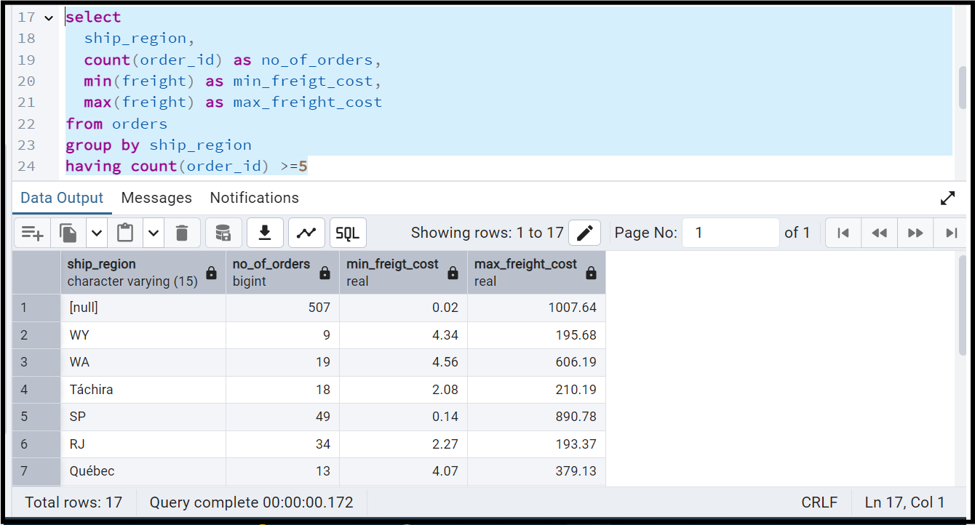

3. Get all title designations across employees and customers ( Try UNION & UNION ALL)

**Query**:

select title as designations from employees

union

select contact_title from customers;

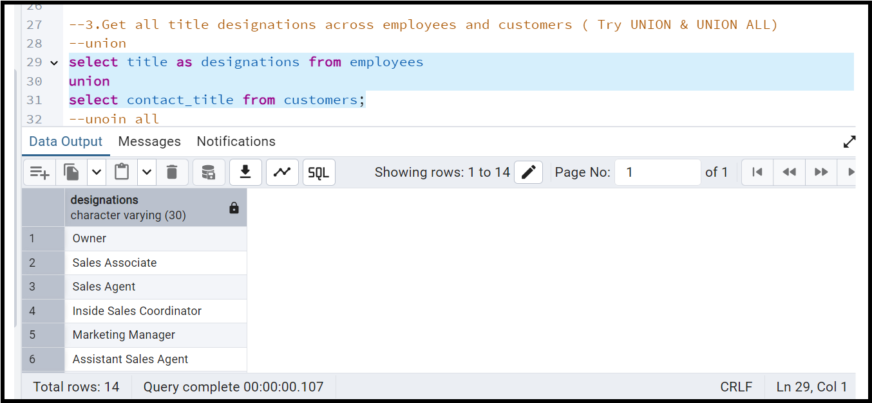

**Union ALL**

select title as designations from employees

union all

select contact_title from customers;

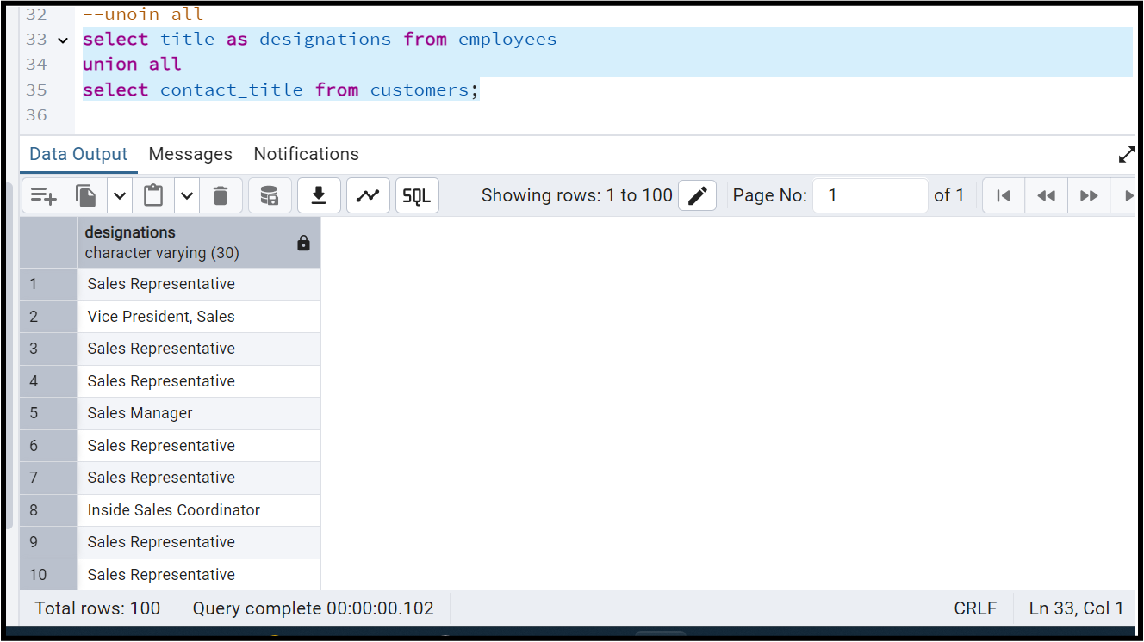

4. Find categories that have both discontinued and in-stock products

(Display category_id, instock means units_in_stock > 0, Intersect)

Ans:

**Query:1**

select category_id,units_in_stock,units_on_order

from products

where discontinued =1

intersect

select category_id,units_in_stock,units_on_order

from products

where units_in_stock > 0

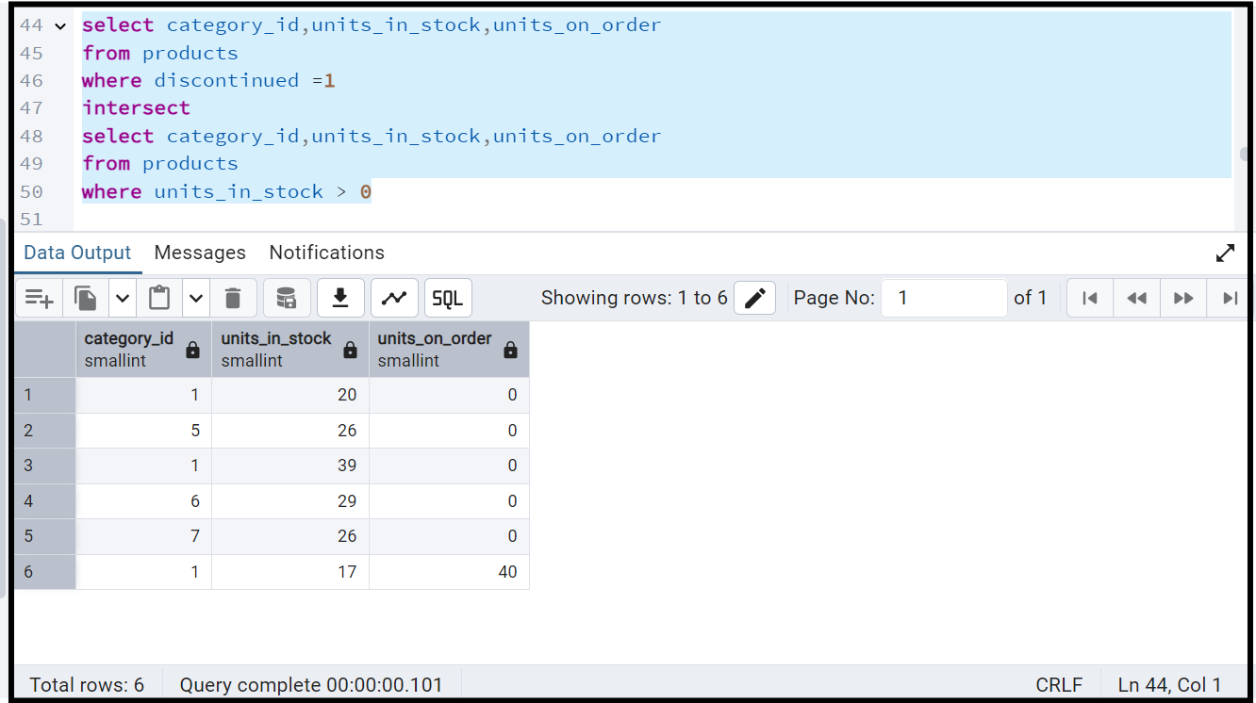

**Query-2**

select category_id,units_in_stock,units_on_order

from products

where discontinued =1

and units_in_stock > 0;

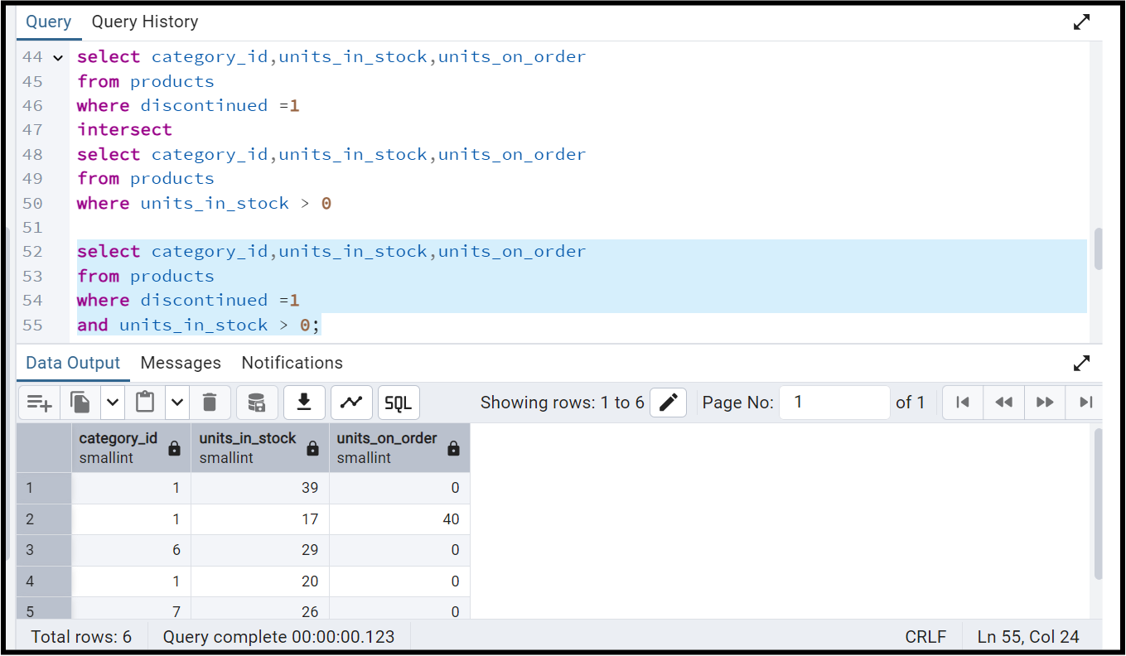

5. Find orders that have no discounted items (Display the order_id, EXCEPT)

**Query:**

select distinct order_id

from order_details

except

select distinct order_id

from order_details

where discount > 0;

